Final Project

Car-Inventory-System-master

Gurwinder Singh

Table of Contents

Project Proposal 2

Project Introduction and Overview 2

Project Specifications 2

Project Goal 2

Project Specifications 2

Target Audience 3

Project Plan 3

Project Deliverables 3

Project Tasks and Milestones 3

Resources Required 4

Project Risks and Assumptions 4

Project Report 4

Aim and Introduction 4

Analysis 4

Functional and Non-Functional 4

Non-Functional 5

Design 6

Project Testing 11

Testing 12

User Manual 14

System Overview 14

System Summary 14

System Configuration 14

User Access Levels 14

# Project Proposal

# Project Introduction and Overview

This project is based on the Car Inventory System master. In this ASP.net project there are two types of account one for admin and other for the user. Admin can add, edit, delete, and access details of the cars. Admin can also edit, delete, and access details of users. Moreover, admin can add more cars, users can see all the cars and buy . user can add, edit, delete, and access details of their accounts. Only registered admin can register new admins.

# Project Specifications

## Project Goal

The main goal of this project is to implement an online web application using Asp.Net. The name of this web application will be “Car Inventory System master” In this application there is admin and users. Admin can manage cars by adding, editing, deleting, and checking details. Also, admin can edit, delete, and check details for various cars. Moreover, users can add, edit, delete, and check details for their accounts. Admin can register new admin and new user can register.

# Project Specifications

* Secure login and registration for the users
* Secure login and admin registration for admins
* Admin can add, edit, delete users
* Admin can manage all the cars.
* Admin can edit, delete, and access details of users.
* userr can edit, delete their details
* users can see all the products

## Target Audience

The main target audience who want a good car for good future. Age group should be 18 plus.

# Project Plan

## Project Deliverables

|  |  |
| --- | --- |
| **Deliverable** | **Description** |
| Project Planning | This document. Introduces the project and elaborates its details and requirements. |
| Project Coding | The application being made. Marking will be based on the GUI, functionality, implementation, and testing. |
| Implementation Details | This document elaborates on the projects details as well as its analysis, design, and implementation. |
| Final Documentation and Report | This includes the final documentation of the project. |

## Project tasks and milestones

|  |  |  |  |  |  |  |  |  |  |  |  |  |  |  |  |  |  |  |  |  |  |
| --- | --- | --- | --- | --- | --- | --- | --- | --- | --- | --- | --- | --- | --- | --- | --- | --- | --- | --- | --- | --- | --- |
| Project Stages | Major Activities | Week-1 | | | | Week-2 | | | | | Week-3 | | | | | | Week-4 | | | | |
| Planning | Technology Research |  |  |  |  | |  |  |  |  |  |  |  |  |  |  |  |  | |  |  |
| First Meeting |  |  |  |  | |  |  |  |  |  |  |  |  |  |  |  |  | |  |  |
| Project Proposal and Documentation |  |  |  |  | |  |  |  |  |  |  |  |  |  |  |  |  | |  |  |
| Phase -1 | Database Design |  |  |  |  | |  |  |  |  |  |  |  |  |  |  |  |  | |  |  |
| User Interface Design |  |  |  |  | |  |  |  |  |  |  |  |  |  |  |  |  | |  |  |
| Phase-2 | Identity framework implementation |  |  |  |  | |  |  |  |  |  |  |  |  |  |  |  |  | |  |  |
| Admin Implementation |  |  |  |  | |  |  |  |  |  |  |  |  |  |  |  |  | |  |  |
| Users Implementation |  |  |  |  | |  |  |  |  |  |  |  |  |  |  |  | |  |  |  |
| Testing |  |  |  |  | |  |  |  |  |  |  |  |  |  |  |  | |  |  |  |
| Final Phase | Final Documentation |  |  |  |  | |  |  |  |  |  |  |  |  |  |  |  | |  |  |  |

## Resources Required

* Microsoft office, excel
* Identity framework
* Asp.Net framework
* Windows Operating System 10 64-bit Processors
* 8 GB or more RAM.

# Project Report

## Aim and Introduction

The project aims to introduce a Car Inventory System master web application which will help users to buy a good car .

# Analysis

### Functional and Non-Functional

The functional requirements of this project are divided into types. One for Admin, and one for users

|  |  |
| --- | --- |
| **Users** | **Functional Requirements** |
| **Admin** | * Login/logout * Register new admin * Manage users * Edit , delete , change customer details |
| **user** | * Login/logout * New user can register themselves. * User can see all products and buy them |

### Non-Functional

|  |  |
| --- | --- |
| **Operational** | * The system should able to run on all web browsers and accessible via mobiles |
| **Security** | * Only Administrators have full access to the system. * Only user have access to their accounts. |

# Design

**Home Page**

This is the landing page of the web app. It consists- Home, brands, models, cars , register , login options on the navigation menu.

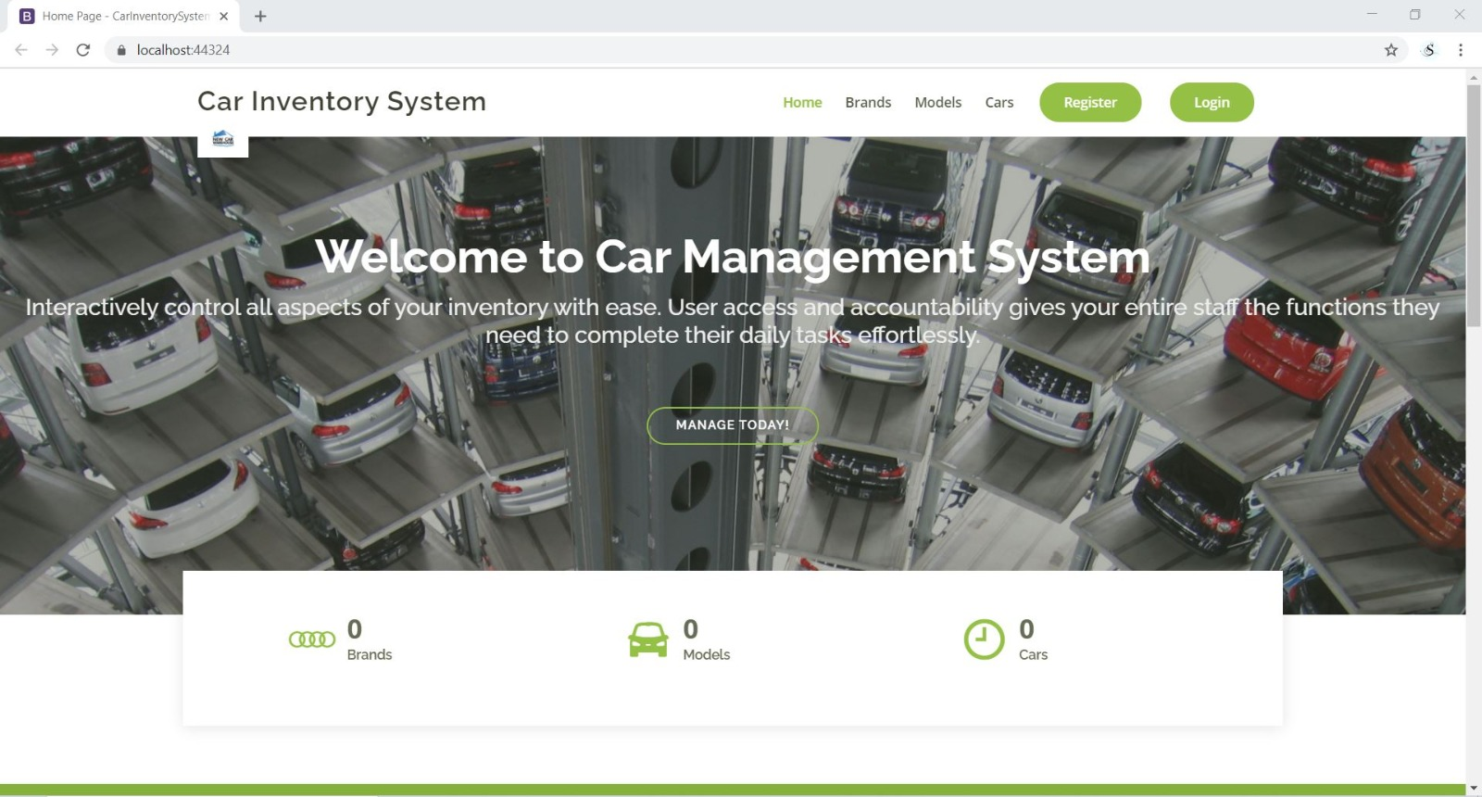

**Brands Page**

This page helps the users to see all the brands on website and buy their favourite brands car .

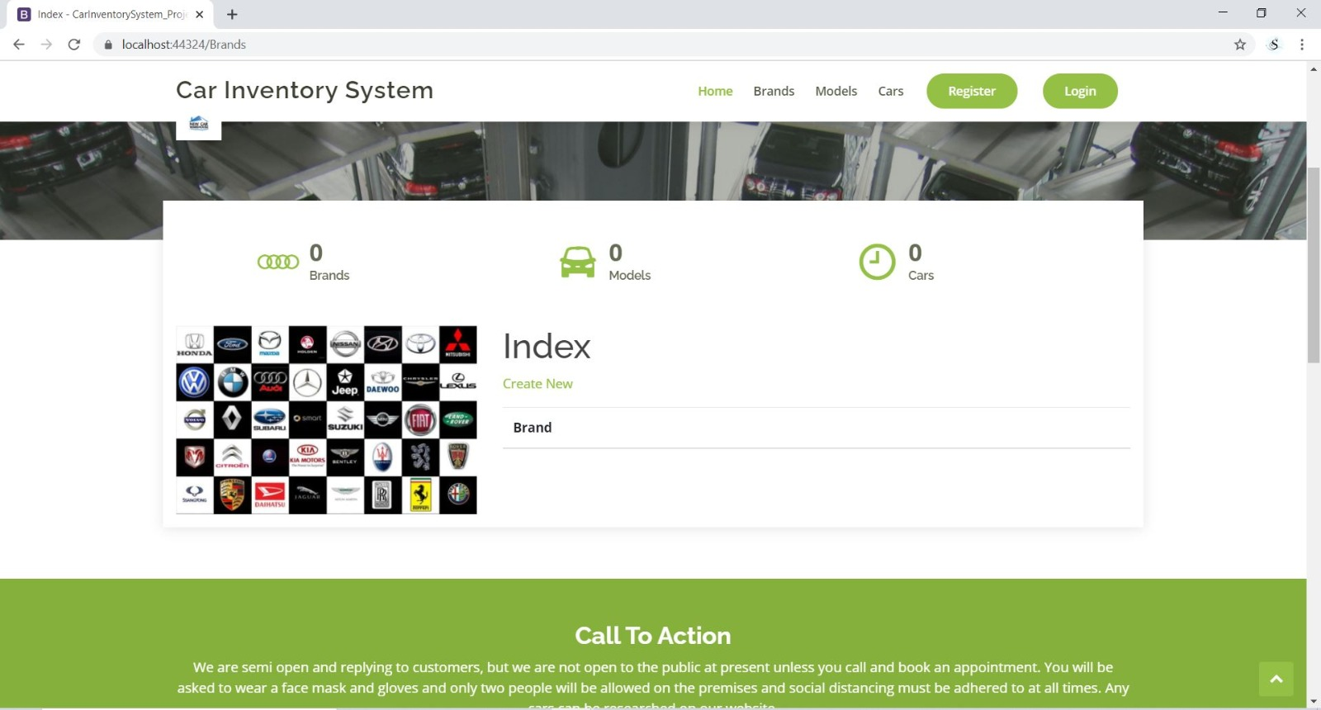

**Models Page**

With the help of this page new users can see all the cars.

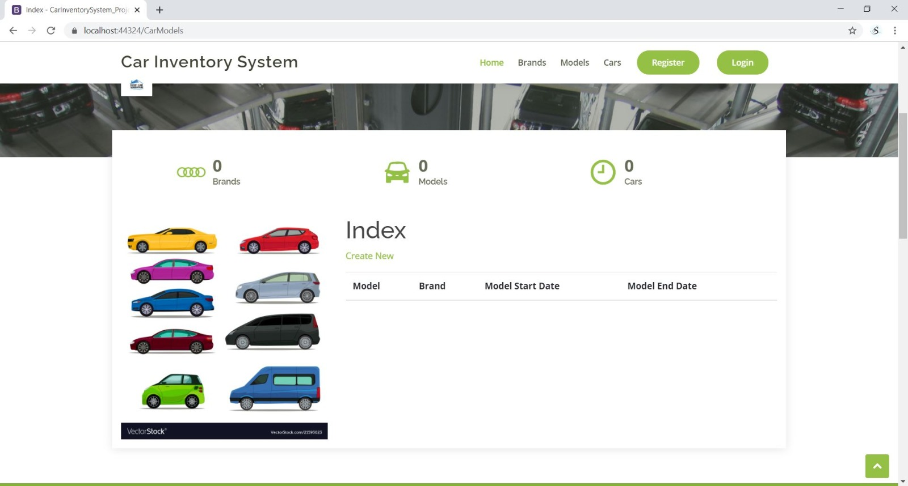

**Admin Registration Page**

With the help of this page admin can register new admin for the application.

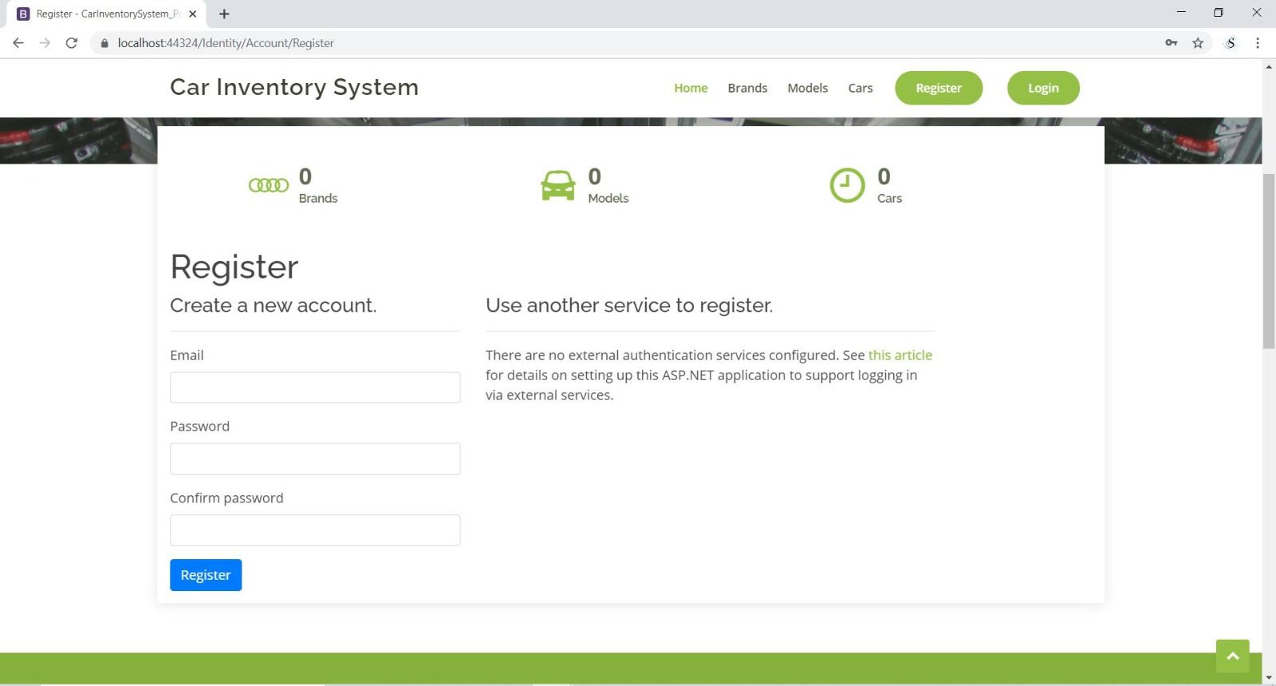

**Login page**

With the help of this page user can login on website.

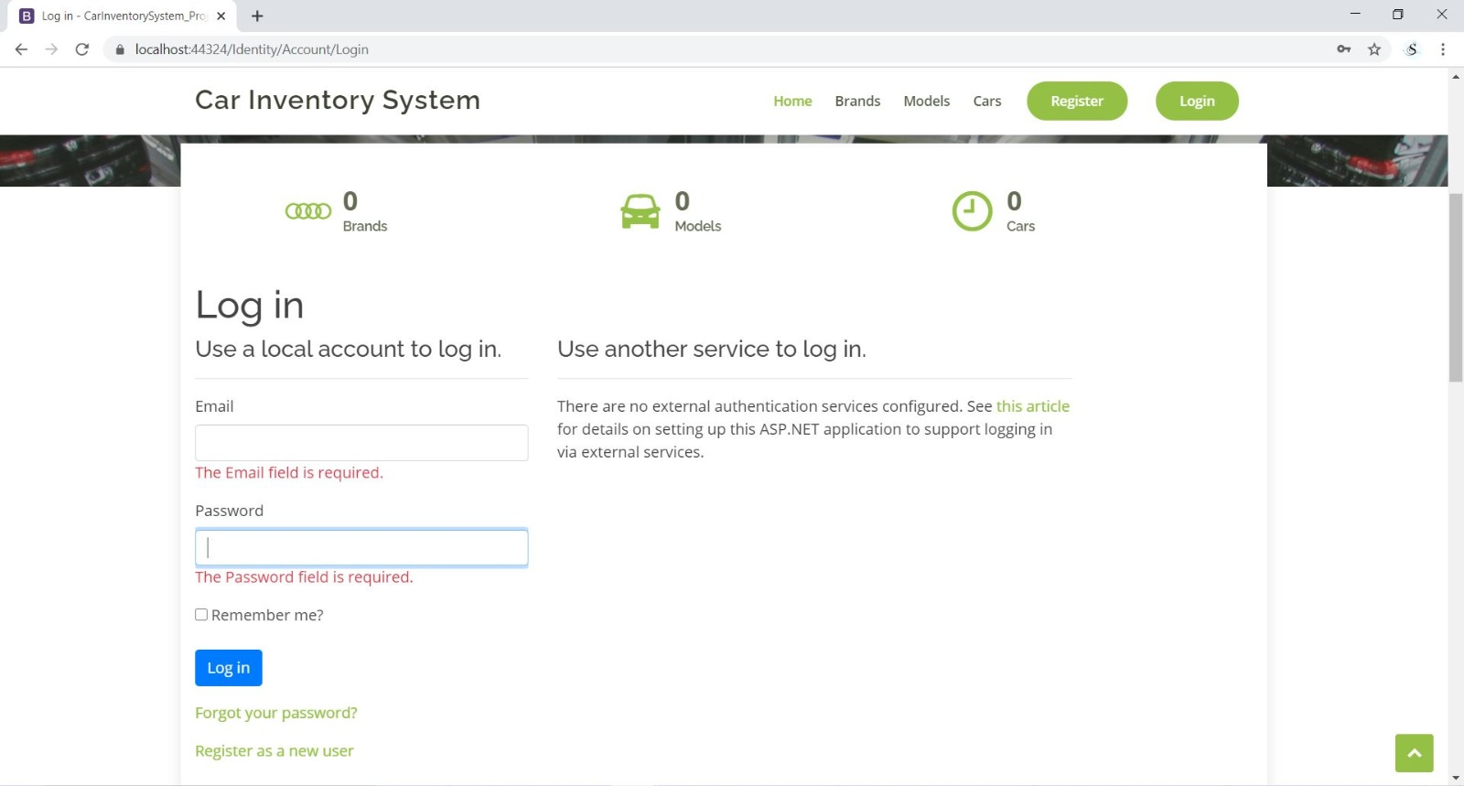

# Project Testing

|  |  |  |  |  |  |  |
| --- | --- | --- | --- | --- | --- | --- |
| **Testing** | | **Answer Scale** | | | | |
| **No.** | **Question** | **Strongly Disagree (1)** | **Disagree (2)** | **Normal (3)** | **Agree (4)** | **Strongly Agree (5)** |
| 1 | I think that I would like to use this system frequently |  |  |  |  |  |
| 2 | I found the system complex |  |  |  |  |  |
| 3 | I thought the system was easy to use |  |  |  |  |  |
| 4 | I found the various functions in this system were well-integrated |  |  |  |  |  |
| 5 | I thought there was too much inconsistency in this system |  |  |  |  |  |
| 6 | I would imagine that most people would learn to use this system very quickly |  |  |  |  |  |
| 7 | I felt very confident using the system |  |  |  |  |  |

# User Manual

### System Overview

Car Inventory System master, In this ASP.net project there are two types of account one for admin and other for the users. Admin can add, edit, delete, and access details of the users. Admin can also edit, delete, and access details of cars. Moreover, admin can delete customers history , new voters can register for the application. users can add, edit, delete, and access details of their accounts. Only registered admin can register new admins.

## System Summary

### System Configuration

Car Inventory System master is a web application developed using Microsoft Visual Studio 2019. It will run on most modern web browsers and will not require any special system configuration.

### User Access Levels

Only registered users can access the features of the app. Also, this app has different types of users; each with different access to the web application’s features.